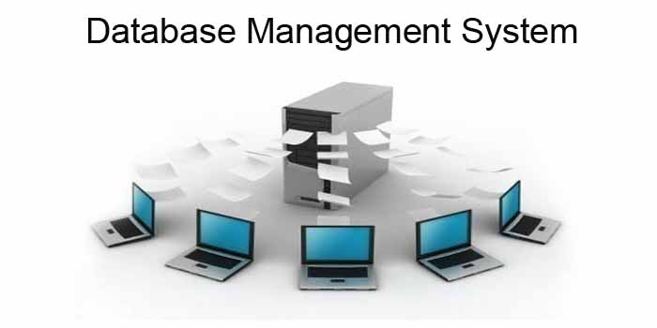

Group Members:

Reaad Kayum USI: 1028635

Lakeram Persaud USI: 1026752

Basudev Singh USI: 1028592

Holika Klass USI: 1021879

Shahrukh Khan USI: 1026738

Course: CSE 2102 – Database Management Systems

Institution: University of Guyana

Table of Contents

1. Mockup of Application Interface
2. Application Functional Specification
3. Project Scope
4. Solution Overview
5. Use Case Specifications
6. System Configuration
7. Non – Functional Requirements
8. Usability
9. Performance
10. Safety
11. Security
12. Error reporting/Exception handling
13. Functional Login Page with Session Handling
14. Mockup of Application Interface

The Interface will most likely look like the following: 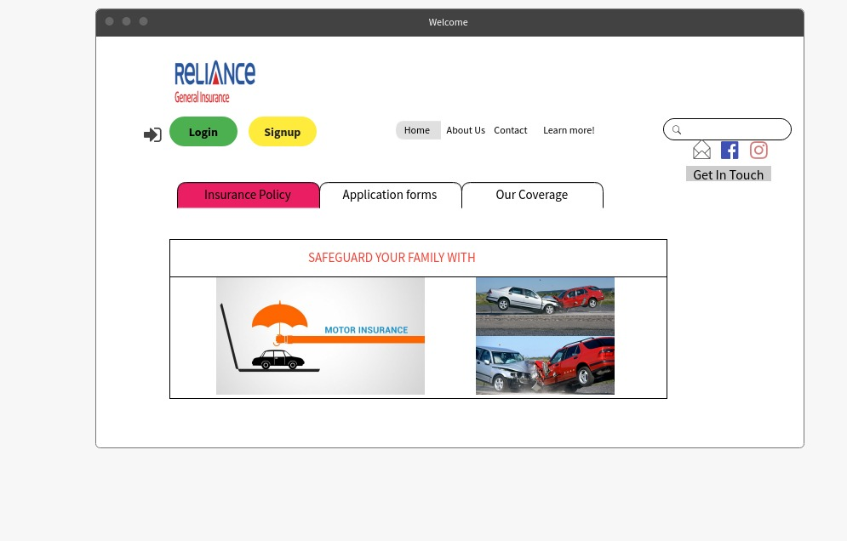

The interface is basically a means for all users to run queries without using the query language itself. In this database for reliance general insurance, it’s the first page the user sees when getting in contact with the database. First time customers will first have to be registered, by clicking register and they will be required to enter their First, last name, email address and password. Employees can register the same way but they will have access to different features of the database for example, the database manager will be able to view and edit where necessary. Customers will only be able to view their insurance status along with other details, while employees will input and update as well as delete or remove data. Apart from registering and logging in, the interface is one of the first marketing tools and how it is displayed and how the information is advertised to the customer will result in how many clients doing business with us. The top right hand of the page shows that we can also be contacted via Facebook and Instagram. While on the left hand there is the contact information and details about who we are as a business.

1. Application Functional Specification
2. Project Scope

This database design is for the local motor insurance company, Reliance General Insurance. This database will be implemented to improve productivity for the company, which was a tedious task to do since they were using a manual method of paper based.

1. Solution Overview

The database requests the user/s to login in to use the system. After authentication, the system allows the user to view the records of Reliance General Insurance which is categorized as Customer and Policy, are allowed to add, edit and delete items in the database. The database is specifically designed to facilitate the collection of data from user input, processing the data and keeping track of customer payment plans, this will intern maximize productivity. By maximizing the companies’ work efficiency and productivity, the system will meet its user’s needs while remaining easy to understand and use.

1. Use case specification

The various user classes identified the following use cases and primary actors for the Motor Insurance Company System:

|  |  |
| --- | --- |
| Primary Actor | Use Cases |
| Database Manager | 1. Add user 2. Remove user 3. Modify user 4. View user 5. Verify user |
| Employee,  Claims clerk | 1. Provide information on the various insurance plans 2. Display insurance plans to user 3. Update insurance plan 4. Help users apply for a plan 5. Generate reports |
| The High-Level Management,  CEO and managers | 1. Access reports 2. Make major corporate decisions 3. handle security and give access to whoever request for it. |

Use case diagram for the motor insurance company system.

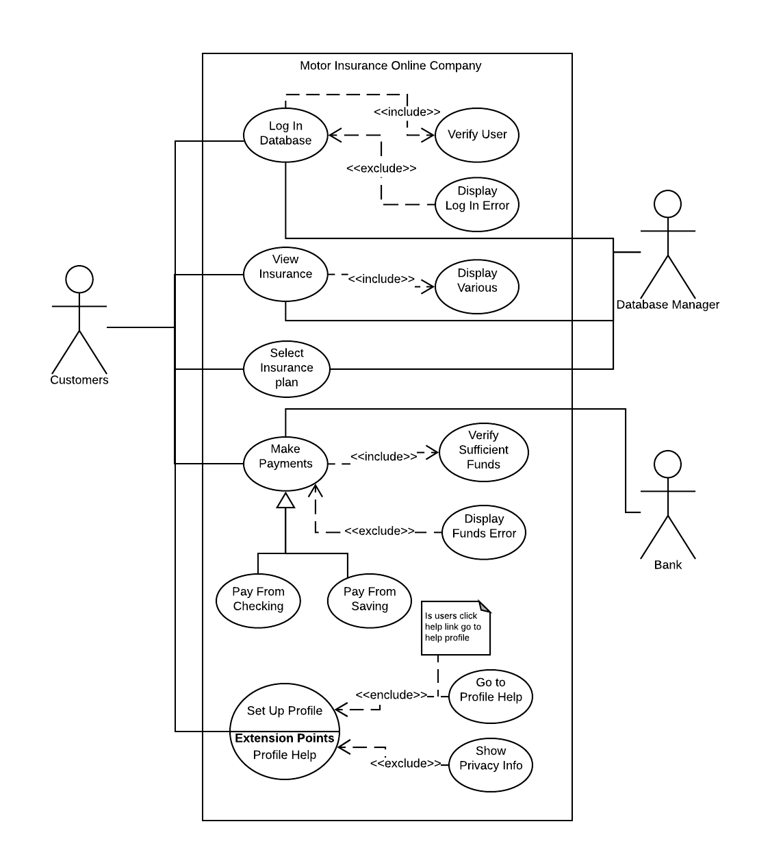

* 1. System Configuration

Simple control system using a universal network

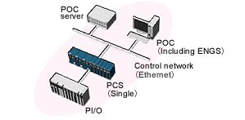

* 1. Non – Functional Requirements

## Usability

The system is easy to handle with basic understandability settings, it accomplishes its goals quickly with no user errors. The interface is easy learn with its straightforward navigation functions such as buttons, headings and help messages that are simple to understand. With its efficiency and friendly user interface, frequent and casual users can interact with the system without any intimidation or frustration.

1. Performance

The system has a 4.8 gigahertz or more processing power with 16 gigabytes of RAM. With those specifications the system is interactive and delays are narrowed to an extreme extent allowing users to quickly, efficiently and with no wasted effort, access and retrieve information promptly.

1. Safety

If there is any great damage to an extensive portion of the database due to some catastrophic event or failure, the recovery method within the system will restore a past copy of the database that was backed up to the archival storage location and redoing all the workings that were done by users up to the time of failure.

1. Security

At the architectural level, security boils down to understanding the precise security requirements for an application, and devising mechanisms to support them. The most common security-related requirements are:

* Authentication: Applications can verify the identity of their users and other

applications with which they communicate.

* Authorization: Authenticated users and applications have defined access rights

to the resources of the system. For example, some users may have read-only

access to the application’s data, while others have read–write.

* Encryption: The messages sent to/from the application are encrypted.
* Integrity: This ensures the contents of a message are not altered in transit.

At a Networking level security is very vital especially a web base application, the data base will be protected by a third-party cyber security team which will monitor data traffic and will implement an intrusion detection system to protect from external attacks.

* 1. Error reporting/Exception handling

1. The application survives the exception and can continue to process events, requests, files etc. Or, the application shuts down gracefully.
2. The relevant parties are notified. These parties include:
   * End users
   * System operators and administrators
   * Developers
   * Customers / owners of the application
3. The exception / error can be diagnosed and reproduced, so it can be corrected.
4. Functional Login Page with Session Hand

Source code for login page can be found at group leader’s GitHub account within the repository.

Link to repository: <https://github.com/ReaadKayum/CSE2102---MOTO-INSURE>

Picture of how login page appears:

